**BIOL 3295 Fall 2017: Test #2**

**Thursday November 16, 2017**

50 mins ~ 13 questions ~ 26 marks

You are permitted to use a calculator

Consider a stage-structured population model with a projection matrix,



with an initial population size of,



where the eigenvalues of *P* are,



and the right eigenvector associated with the dominant (or leading) eigenvalue is,



The formula to calculate the population size at time *t* is,



1. For the stage-structured population model given above, will the population increase in abundance over time? How do you know? [2]
2. Calculate the population size for each stage at time, *t = 1*, using the *N*t+1 formula above. [2]
3. For each stage, divide the number of individuals in that stage at time, *t* = 1 (question 2), by the number of individuals in that stage at *t* = 0. Comment on the significance of your answer. [2]
4. For the calculated population size at *t* = 1 (question 2), calculate the fraction of individuals in each of the stages relative to the total population size at *t* = 1 (note: the denominator in this calculation should be the sum of the number of individuals in each of the stages at *t* = 1). Comment on the significance of your answer. [2]
5. For a metapopulation model, explain the difference between the colonization term given a “propagule rain” formulation (Gotelli 1991) and the colonization term that was used in the other metapopulation models that we studied [2]
6. Assuming that sea otter colonization of the California coast meets the assumptions of a reaction diffusion model, sketch a graph of time (on the horizontal axis) and the most northern point in space that the otter population has been detected at that time (on the vertical axis): [1]

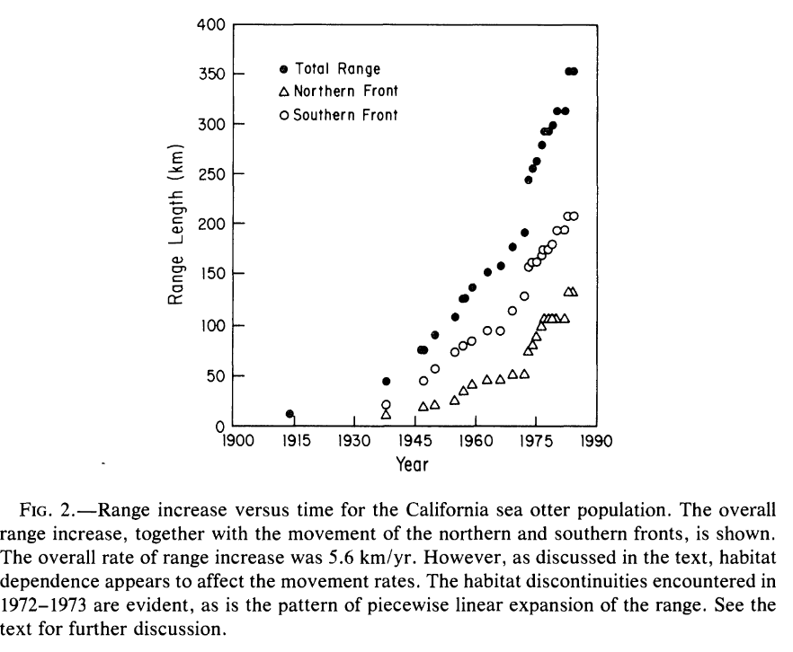

1. The graph above shows actual sea otter colonization to the California coast. The authors of this study (Lubina and Levin 1988) suggest that an assumption of the reaction diffusion model that was not met became evident in 1972-1973. What was this assumption? [2]
2. State one assumption of a reaction diffusion model that pertains to dispersal of the individuals and is different from the answer you gave in 7. [1]



1. The logistic growth model is not appropriate to study questions related to climate

change due to the assumptions this model makes. Why can this model not be used/how should it be changed to understand how populations respond to climate change? [2]

1. What are eco-evolutionary dynamics? [2]
2. Give one example of evolution affecting ecology (or population dynamics/biology). [2]

Life History 1:

|  |  |  |  |
| --- | --- | --- | --- |
| age, *x* | 1 | 2 | 3 |
| *lx*: Prob of surviving to (at least age), *x* | 0.9 | 0.8 | 0.5 |
| *mx*: Fecundity at age, *x* | 0 | 0 | 10 |

Life History 2:

|  |  |  |  |
| --- | --- | --- | --- |
| age, *x* | 1 | 2 | 3 |
| *lx*: Prob of surviving to (at least age), *x* | 0.8 | 0.5 | 0.4 |
| *mx*: Fecundity at age, *x* | 0 | 5 | 5 |

1. For Life History 1 and Life History 2, describe the types of trade-offs represented [2]
2. Use the Euler-Lotka equation to calculation the lifetime reproductive output, R0, for individuals with Life History 1 and Life History 2. Assuming that these life history strategies are heritable, which life history has higher fitness (R0) and will be favored by natural selection? [3]